Plant responses
- What are the three types of stimuli that plants respond to?
.......................................... ............................................ ..............................................
- What is a tropism?
..................................................................................................................................................
- What are the names of the three different types of tropisms?
.......................................... ............................................ ..............................................
- Why do plants grow towards light?
..................................................................................................................................................
- Annotate the diagram to explain why the plant grows towards the light
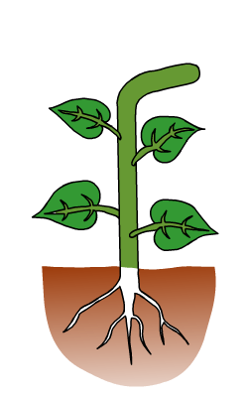
- How do plants respond to gravity?
Shoots...............................................................................................................................
Roots.................................................................................................................................
- Annotate the diagram to explain the responses of roots and shoots

