If particles are packed closely together so they cannot move around they form........ | Which state of matter contains particles that are far apart?
Gases Liquids Solids | Gases Liquids Solids
What is made up of particles that are packed closely together, but can move over and around each other? | Which word is spelled correctly to describe tiny pieces of matter?
Gases Liquids Solids | Particals Particles Particels
Which state of matter can be easily compressed? | When you heat a solid it......
Gases Liquids Solids | Freezes Contracts Expands

When you cool down a solid it.... | What is this?  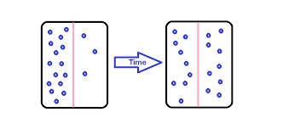
Expands Contracts Melts | Diffusion Melting Freezing
Density = mass divided by ?????? | When a solid changes to a liquid it.....
Size Volume Temperature | Boils Condenses Melts
When a liquid changes to a gas it..... | When a gas changes to a liquid it.....
Freezes Evaporates Condenses | Condenses Melts Freezes

When a liquid changes to a solid it..... | If a material changes from a solid to a gas it...
Condenses Melts Freezes | Condenses Melts Sublimes
This random movement of particles is called:  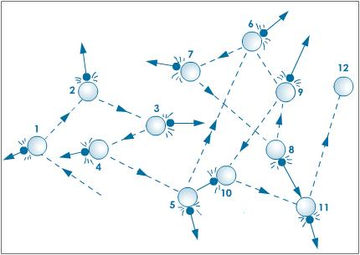 | Which of the following is solid at room temperature?
Brownian Greenian Diffusian  Motion motion motion | Iron Water Oxygen
It has a fixed shape and size. | Helium is a...
Gas Liquid Solid | Gas Liquid Solid

It flows from one  container to another. | Mercury is a...
Gas Liquid Solid | Gas Liquid Solid
The following picture represents particles in...  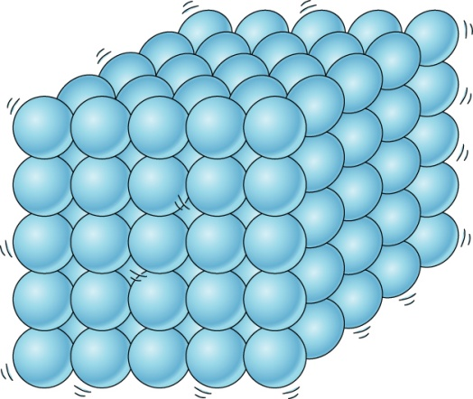 | It fills any container  you put it in.
Gas Liquid Solid | Gas Liquid Solid
The following picture represents particles in...  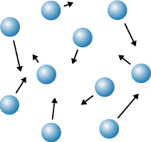 | The following picture represents particles in...  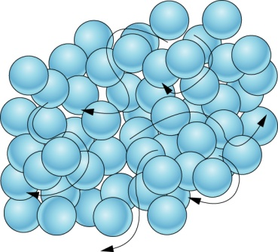
Gas Liquid Solid | Gas Liquid Solid

When a balloon is squashed the air particles...  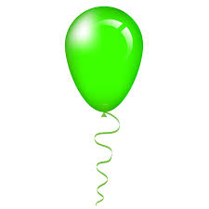 | These materials have the lowest density
Get move join  smaller closer up | Gases Liquids Solids
How does a smell travel? | When particles are heated they move...
Diffusion evaporation dissolving | Slower faster same  speed
Ice is a.... | Boiling point of water is...
Gas Liquid Solid | 10°C 90°C 100°C

