Challenge 1
FIND OUT?
Use a textbook or the internet to find out about:
Metal recycling
How are different types of metals recycled?
How does this benefit the environment?
Try http://www.recyclemetals.org

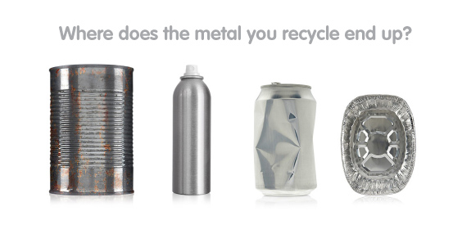
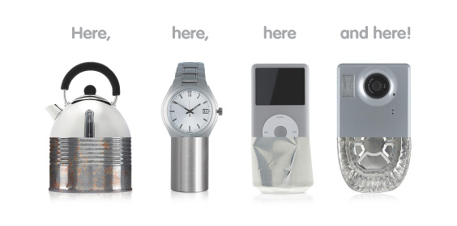

Challenge 2
WHAT IF?

There were no metals

Imagine that aliens have arrived with a giant metal-removing hoover and there are no more metals on earth.
What problems would this cause?
What alternatives could we use for things that we currently use metals for?
Would we even survive?

Challenge 3
Passport control – you need to work in a pair for this Challenge.
Imagine you are working at The Periodic Table Passport Control at the border between metals and non-metals. Only metals are allowed to pass into the left of the periodic table. What questions could you ask elements to decide if they are a metal or non-metal?
What would you expect the answer from a metal to be?
In your pair, come up with a role play, where one of you is the Passport Controller, and the other one is a metal or non-metal trying to cross the border.

Challenge 4
A | B | C | D | E | F | G | H | I | J | K | L | M | N | O | P | Q | R | S | T | U | V | W | X | Y | Z
15 | 18 | 23 | 8 | 9 | 6 | 5 | 11 | 3 | 4 | 22 | 7 | 14 | 0 | 12 | 19 | 24 | 25 | 1 | 13 | 21 | 20 | 17 | 2 | 16 | 10

14, 9, 13, 15, 7 /23, 15, 25, 18, 12, 0, 15, 13, 9, 1/15, 25, 9/14, 15, 8, 9/12, 6/15/14, 9, 13, 15, 7/

23, 15, 25, 18, 12, 0/15, 0, 8/12, 2, 16, 5, 9, 0.

14, 9, 13, 15, 7 /23, 15, 25, 18, 12, 0, 15, 13, 9, 1/25, 9, 15, 23, 13/17, 3, 13, 11/15, 23, 3, 8/13, 12

19, 25, 12, 8, 21, 23, 9/15/14, 9, 13, 15, 7/1, 15, 7, 13/23, 15, 25, 18, 12, 0/8, 3, 12, 2, 3, 8, 9/15, 0, 8

17, 15, 13, 9, 25.

Challenge 5
TABOO
You need two players for this game.
DO NOT LET YOUR PARTNER SEE THIS SHEET.
Try to describe the following items to your partner without saying any of the “taboo” words. If they get it right, give it a tick and move on to the next one.
metal  taboo words:  non-metal, silver, gold, hard, shiny | rust  taboo words:  iron, orange, nail, oxygen | Carbon dioxide  taboo words:  gas, breathe, limewater
hydrogen  taboo words:  water, oxygen, squeaky pop | alloy  taboo words:  mixture, brass, steel | reactivity  taboo words:  reactions, metals, fizzing
gold  taboo words:  unreactive, silver, jewellery, Au | sodium  taboo words:  reactive, water, Na | Periodic table  taboo words: metals, non-metals, elements

Now look at the following items together – if you were making this game which taboo words would you choose?
Silver
Reactant
Product
Salt

Challenge 6
Comparing metals and non metals.
Ask your teacher for a printed copy of this sheet.
Carefully read through the following piece of writing. Look for statements that are about elements.
- highlight the parts about metallic elements in blue;
- highlight the parts about non metallic elements in red.

Brass is a shiny metal that has lots of decorative uses e.g. letterboxes. Gold is also shiny but it is also quite rare and therefore valuable. Diamonds are also valuable and these are made from carbon atoms. Non metals like sulphur are not usually shiny nor do they normally conduct electricity. Graphite is a form of carbon that is unusual because it is a non metal that conducts electricity.
Iron is a strong metal. Steel is also strong but because it contains a small amount of carbon atoms (making it an alloy) it is much harder than iron. Glass is also hard but it does break easily. Metals don’t usually break because they are flexible and bend which makes them very useful for making things from.
Copper, like all metals can be made into wires (it is ductile) and it is also a very good conductor of electricity. Metals also conduct heat so copper and aluminium are used to make saucepans. Some frying pans are made from stainless steel and have a coating of “Teflon” on them to stop the food sticking. Teflon is made from carbon, hydrogen and fluorine. Wood and plastic are used to make the handles of some saucepans because they do not conduct heat readily.
Without silicon, our phones, computers and cars would not work as it’s this element that makes up the chips which control them.
Non metals like ice and wax usually melt easily. Sulphur melts easily in a Bunsen flame whereas iron melts at 1535 degrees C which is why its atoms are used to make the Bunsen burner. Iodine is a little strange because it goes straight from being a solid to a gas at 114 degrees C.
Most metals e.g bronze and steel are heavy and a few are magnetic i.e. iron, nickel and cobalt. Metals are also sonorous which means they make a ringing sound when hit.

Now find and write down the chemical symbols for all the elements mentioned above.
Challenge 7
Metal compounds
Useful information:
A number before an element means there are so many lots of that compound.
E.g. 5H₂ = 5 Molecules of Hydrogen 3H₂0 = 3 molecules of water
A small subscripted number after an element means that only the element before it is present in that amount.
E.g. H₂SO₄ = 2 Hydrogen atoms, 1 Sulphur atom, 4 Oxygen atoms.
A small subscripted number after a closed bracket indicates that only elements in the bracket are multiplied by that amount.
E.g. Ca(OH)₂ = 2 oxygen atoms and 2 Hydrogen atoms but only 1 Calcium atom.
Work out the number of atoms for each element in the following compounds. The first one has been done for you:

3Mg(NO₃)₂ Mg = 3 H₂O₂
N = 6
O = 18

3MgO 3H₂CO₃

C₆H₂(OH)₄ 2Mg₂(PO₄)₃

H₂SO₄ Ca(NO₃)₂

