Challenge 1

FIND OUT?

Use a textbook or the internet to find out about:

DMITRI MENDELEEV

Who was he?

What did he discover?

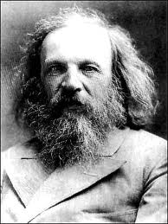

Challenge 2

WHAT IF?

You were an element?

Which one would you be and why?

Challenge 3

Cartoon elements

Use the periodic table to find the symbols for the groups of elements below. Each group should spell a different cartoon character

Tungsten, oxygen, oxygen, dysprosium ____________________

Phosphorus, iodine, nitrogen, nobelium, carbon, hydrogen, iodine, oxygen ________

Sulphur, hydrogen, rhenium, potassium ______________

Tin, oxygen, oxygen, phosphorus, yetrium ________________

Carbon, hydrogen, iodine, phosphorus ____________________

Samarium, iodine, thorium, erbium, sulphur ____________

Sulphur, cobalt, oxygen, boron, yetrium _______________

Boron, aluminium, oxygen, oxygen _______________

Aluminium, iodine, cerium ________________

Oxygen, scandium, argon ___________

Polonium, calcium, hydrogen, oxygen, nitrogen, tantalum, sulphur ______________

Phosphorus, iodine, potassium, actinium, hydrogen, uranium _____________

Scandium, radium, technetium, hydrogen, yetrium _____________

Challenge 4

Cartoon elements 2

Artist Kacie D has drawn a character for each element in the periodic table, their characteristics are based on the properties of that element. Two are shown here. Can you design one for a different element?

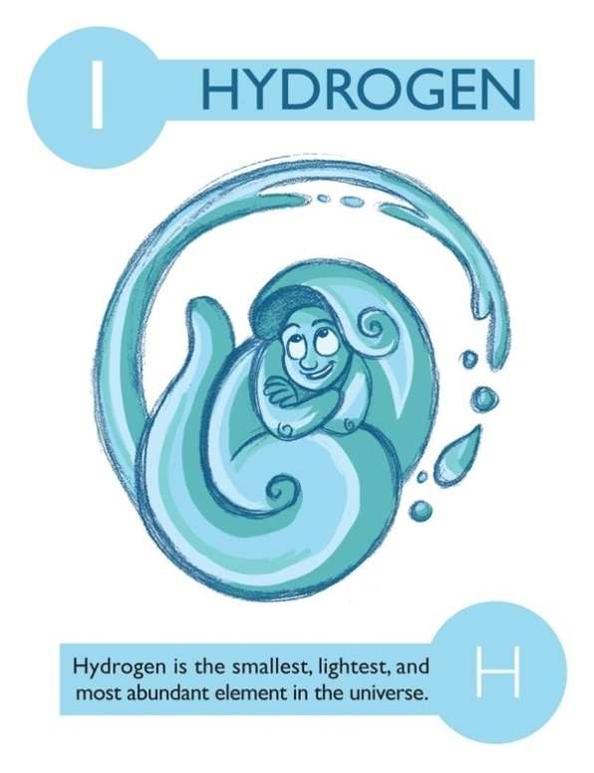

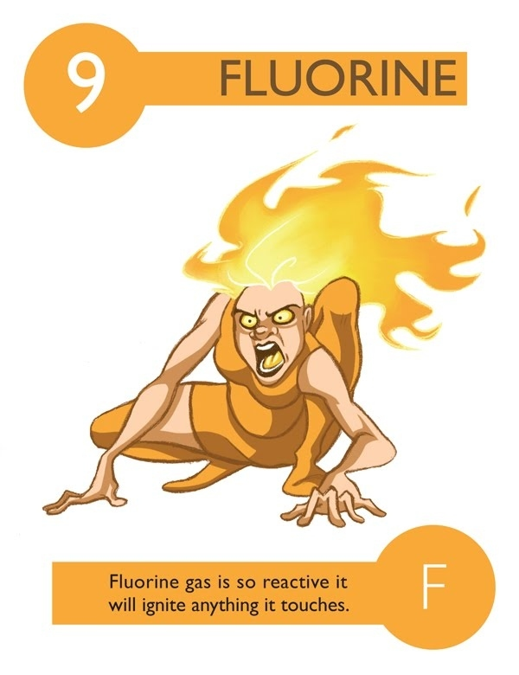

Challenge 5

Can you crack the code?

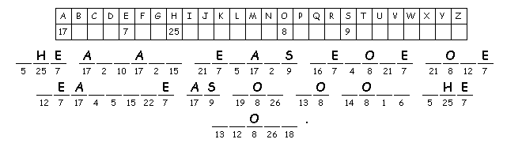

Challenge 6

Ask your teacher for a paper copy of the text about scientists and their discoveries.



Then – the diagram below shows some different ways in which scientists can work. Can you match these with some of the scientists from the text?





 



 

Challenge 7

**Periodic Table Quiz**

1. Element named after a planet. ………………………………………

2. Two metallic elements that are **not** silver or grey. ……………………………………

3. Found in the kitchen but spelt differently. …………………………………………

4. Could be a valley in California. ……………………………………………

5. Yellow non-metal. ………………………………………

6. American 5cent. ………………………………………

7. Green poison. ……………………………………..

8. A black bird? …………………………………….

9. Does not like coins or banknotes? ………………………………………

10. € …………………………………..

11. Definitely male, but not helium. ……………………………………..

12. Could be named after France? …………………………………….

13. Could be named after Germany? …………………………………….

14. Superman element. …………………………………………

15. Very rude element. ............................................

Challenge 8

Challenge 9

Periodic table mnemonics

Suppose that you wanted to remember the names of the elements in the periodic table, in order.

One way of doing it is this rather strange rhyme:

**Ha Ha Hee.**

**Libeb Canofnee.**

**Namgalsi Pasclar.**

At first glance this doesn’t seem to make a lot of sense.

This is how the first two lines translate to the element sequence:

**Ha Ha Hee --> H He**

**Libeb Canofnee --> Li Be B C N O F Ne**

Can you work out what the third line of the rhyme shows?

If you wanted to remember the order of, say, the first twenty elements in the table, how would *you* do it?