Challenge 1

FIND OUT?

Watch the following clip to find out about the experiments of van Helmont in investigating plant growth.

<http://www.bbc.co.uk/education/clips/zpgb4wx>

|  |
| --- |
| http://lrrpublic.cli.det.nsw.edu.au/lrrSecure/Sites/LRRView/7397/applets/Living_Things_Database/livingthings/images/willow.gif |

Write a brief summary of the clip describing van Helmont’s experiment.

Challenge 2

WHAT IF?

There were no plants?

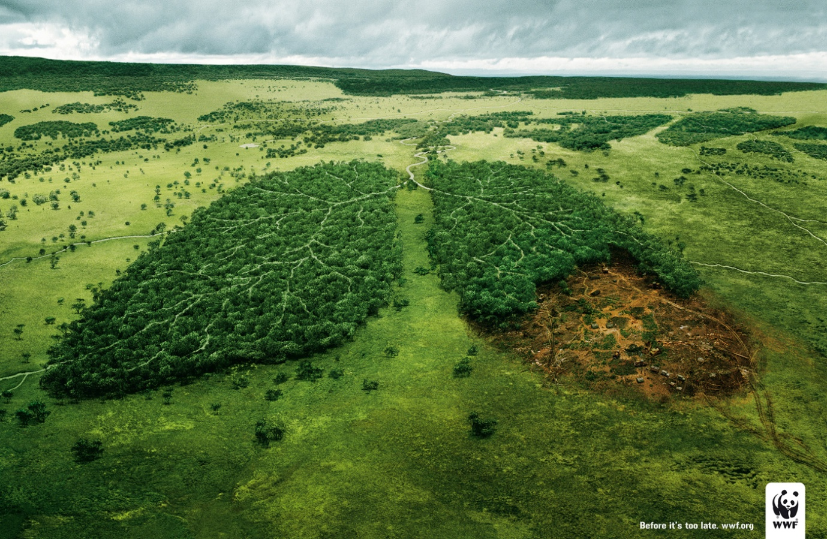

Would humans survive? If so, for how long?

What important things do plants provide?

Is there an alternative way for us to get these things?

Challenge 3

Joseph Priestley

1. Read the following information and letter

Joseph Priestley was a preacher who was born in 1733 in Yorkshire, England. His enthusiasm for natural sciences began when he was 35 years old and he was well known for his work on gases. He lived next to a brewery, where he became interested in the role of gas in alcohol fermentation. He researched the properties of this gas (which is now known as carbon dioxide), and by adding it to water invented soda water. In addition, he also discovered a gas which would be named three years later, by the French scientist Lavoisier, as oxygen. Priestley also discovered that animals and humans ‘consume air’ and that plants’ can give the air back its freshness’. How this process – photosynthesis – works, was only discovered in 1862, almost 100 years after Priestley’s discovery.

Joseph Priestley’s letter to his friend Benjamin Franklin (1 July 1772)

London,

1. July 1772

I am fully convinced that the air, which is made harmful by our breathing out, can be restored through plants.

I have gathered used up air in a container and sealed this container hermetically. Seven days later, I placed a mouse into this container. In another container with the same used up air, I placed a plant. Seven days later I placed a mouse in the same container where the plant was.

The mouse which was in the container without a plant died after 5 seconds. The mouse placed in the container with a plant, lived happily in the container for many minutes. Then I took the mouse out and placed it in the other container without any plants in. This poor mouse, which did so well in the container with the plant in, had to be taken out and resuscitated after spending as little as two seconds in the container without plants. This experiment shows us that plants can give the air its freshness back.

Kind regards

Joseph Priestley

Draw and label a diagram that Priestley could have added to his letter to help explain his experiment to his friend.

Challenge 4

TABOO

You need two players for this game.

DO NOT LET YOUR PARTNER SEE THIS SHEET.

Try to describe the following items to your partner without saying any of the “taboo” words. If they get it right, give it a tick and move on to the next one.

|  |  |  |
| --- | --- | --- |
| Carbon dioxide  Taboo words – gas, oxygen, breathe | chloroplasts  Taboo words – leaf, cell, green | photosynthesis  Taboo words – process, plant,  carbon dioxide |
| Glucose  Taboo words – sugar, plant, photosynthesis | Leaf  Taboo words – plant, green, stem | Oxygen  Taboo words – gas, breathe,  carbon dioxide |
| Palisade  Taboo words – cells, leaf, chloroplasts | Root  Taboo words – plant, ground, water | Sunlight  Taboo words – shine, sky, energy |

Now, think of some more examples from this topic, including the taboo words to use with them.

Challenge 5 Carbohydrates



We know that the food plants made from photosynthesis are called CARBOHYDRATES.

Carbohydrates contain the atoms CARBON, HYDROGEN and OXYGEN.

The carbohydrate shown above is called glucose.

1. Which part of the word “carbohydrate” suggests that it contains carbon?
2. Which part suggests that it contains hydrogen?
3. What does “ate” mean, do you think?
4. Count the atoms – how could we write the formula for glucose?
5. During photosynthesis what molecules does a plant use?
6. What molecules does it produce?
7. Can you write the word equation for photosynthesis?
8. Can you write a symbol equation? Can you balance it?

Challenge 6 – ask your teacher for a paper copy of this one

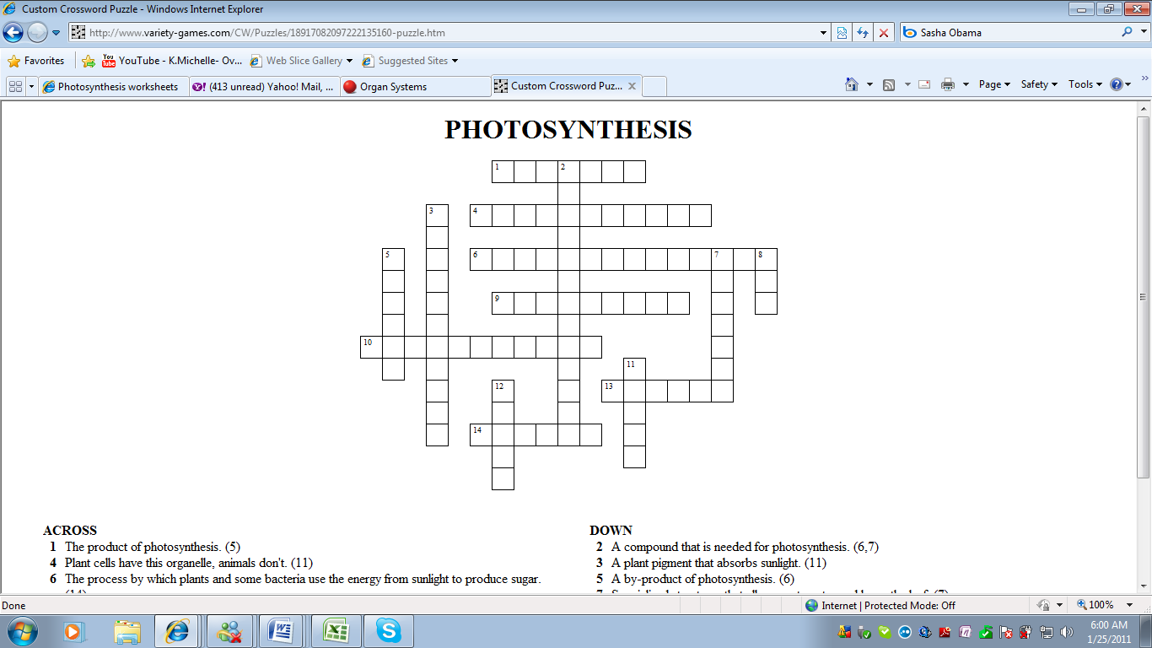

|  |  |
| --- | --- |
| ACROSS   1. The product of photosynthesis (5)   4. Plant cells have this organelle, animal cells don’t (11)  6. The process by which plants and some bacteria use energy from sunlight to make sugar (14)  9. The links between the energy that carnivores get from eating to the energy captured by photosynthesis (4, 5)  10. This process results in the production of energy in cells (11)  13. The flat part of the leaf (6)  14. Part of the plant where photosynthesis generally occurs (6) | DOWN   1. A compound that is needed for photosynthesis (6, 7) 2. A plant pigment that absorbs sunlight (11) 3. A by-product of photosynthesis (6)   7. Specialised structures that allow gas to enter and leave the leaf (7)  8. Number of molecules of oxygen produced along with one molecule of sugar (3)   1. A compound needed for photosynthesis (5)   12. Chlorophyll absorbs every colour of light except this (5) |

Challenge 7 [**ENERGY INNOVATION**](http://www.smithsonianmag.com/specialreports/energy-innovation-180947981/)

|  |  |
| --- | --- |
| http://blogs.smithsonianmag.com/ideas/files/2013/10/algae-street-lamp-web.jpg | Can an Algae-Powered Lamp Quench Our Thirst For Energy?**A French chemist is developing street lights that can absorb carbon dioxide 200 times more efficiently than trees** |

There’s something very special about bioluminescent algae. They soak up sunlight, absorb carbon dioxide, and in return, breathe out oxygen while emitting a soft fluorescent glow. In essence, it’s nature’s all-in-one version of a solar panel, a carbon sink and a light bulb.

French biochemist Pierre Calleja has spent several years working on a way to harness the microorganisms’ special abilities to help mitigate some of planet Earth’s most pressing problems, namely global warming, threats to ecosystems and the need for renewables. His solution comes in the shape of a cylindrical algae-powered lamp that requires no electricity and is thus completely self-sufficient, operating through a process wherein all the energy produced during photosynthesis is collected and stored in a battery that helps to power the light during the evenings.

But how much of a difference maker can these goopy little marine organisms be? I mean no one’s ever heard of a lamp saving the world. Well, the fact is that microalgae is incredibly efficient at removing carbon dioxide from the atmosphere, about 150 to 200 times more than trees. Basically, an algae lamp can remove as much CO2 in one year as a tree would in its lifetime. Also, extracting algae from aquatic environments, such as oceans, could potentially save fish and other marine life since rapid increases known as algal blooms have caused widespread mortality due to harmful toxins that are sometimes released.

But bio-engineering such a dream scenario isn’t without its challenges. Skeptics are still waiting to hear how Calleja plans to overcome some of the plant’s problematic properties, such as the “light-smothering qualities of dense plumes of algae” and maintenance to prevent the ”dirty fishbowl” effect in which a murky buildup starts to accumulate on the glass lamp over time.  
  
TASK - Write a definition for the words that are underlined.  
EXTENSION – watch the TED talk about this topic https://www.youtube.com/watch?v=5KPdA-qWNdQ#t=10

Challenge 8 CONCEPT MAP

USE THE WORDS BELOW TO PUT TOGETHER A MIND MAP FOR THIS TOPIC

